EarthOverView

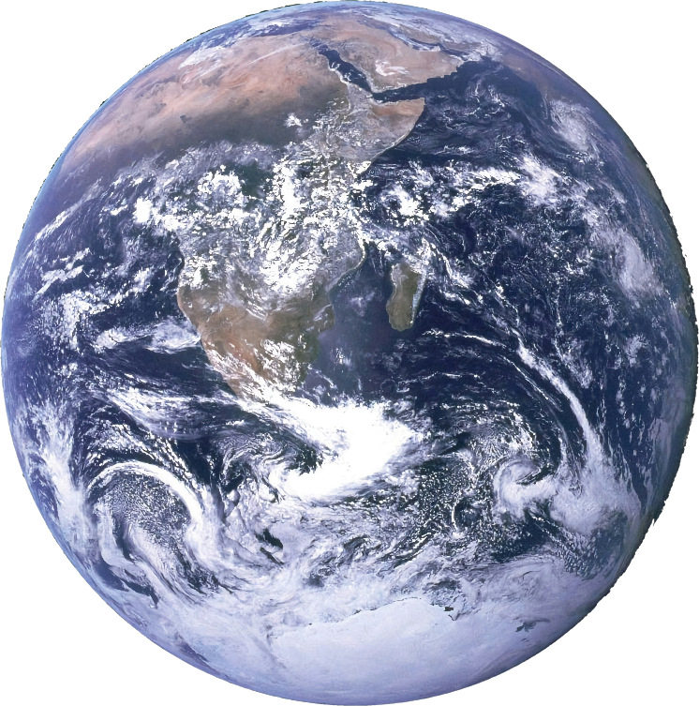

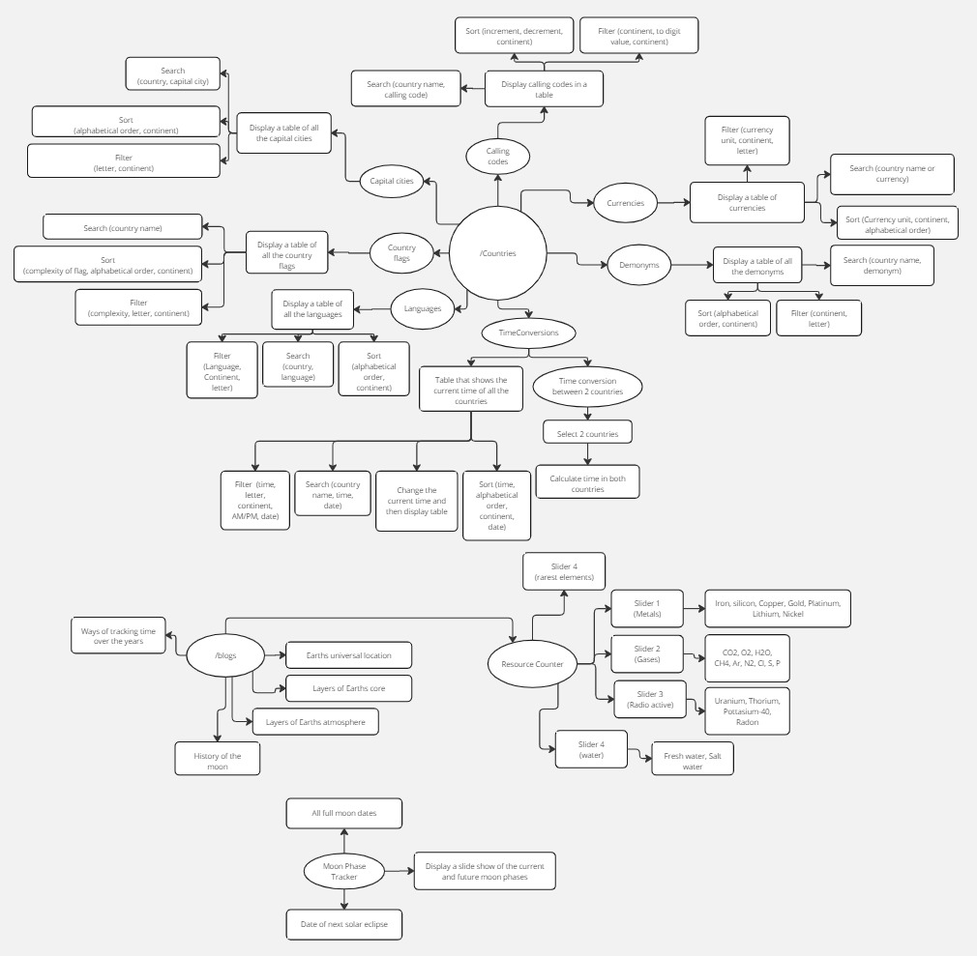Flow Chart

Miro.com view link:  
<https://miro.com/welcomeonboard/V3R3cmw2UWZPTm9kR1Q0d25NckttWGxscWpKa1RQYktyekNkeHB6a0dEdlQwdlJZSjhJR3NJNHMxbkM1M2FGenwzNDU4NzY0NTk1Mjk0MDgwNDMxfDI=?share_link_id=184347047932>

Linking hierarchy:

* EarthOverView
  + Countries
    - CallingCodes
    - Currencies
    - Demonyms
    - TimeConversions
    - Languages
    - CountryFlags
    - CapitalCities
  + Blogs
    - UniversalLocation
    - Core
    - Atmosphere
    - Moon
    - Time
    - ResourceCounter
  + MoonPhaseTracker

Use Cases and Requirements

Calling Codes

Main Scenarios:

1. User searches up a country and obtains the relevant calling codes
2. User searches up a calling code and obtains the relevant country
3. User sorts the calling codes in ascending/descending order
4. User filters only the calling codes in Southern Asia

Design requirements:

Search bar, search selector, filter and sort buttons, A table with the following columns: Country, Continent, Calling code.

Technical requirements:

API: JavaScript, tailwind

Currencies:

Main Scenarios:

1. User filters a currency unit and obtains the countries with the currency unit
2. User searches a country and obtains the currency
3. User copies a currency symbol
4. User searches for the currency code of a currency

Design requirements:

Search bar, search selector, filter and sort buttons, A table with the following columns: Country, Continent, Currency name, Currency Unit, Currency code, symbol.

Technical requirements:

API: JavaScript, tailwind

Demonyms:

Main Scenarios:

1. User searches a country and obtains demonyms
2. User filters demonyms in alphabetical order

Design requirements:

Search bar, search selector, filter and sort buttons, A table with the following columns: Country, Continent, Demonyms.

Technical requirements:

API: JavaScript, tailwind

Time Conversions:

Main Scenarios:

1. User selects 2 countries (his own and another) and will convert the time between the 2.
2. User types in a name of a country to find the time of that country
3. User filters countries depending on weather it is day or night

Design requirements:

2 selectors to select 2 countries.

Search bar, search selector, filter and sort buttons, A button to switch between 12 hour and 24 hour time formats A table with the following columns: Country, Continent, Time, AM/PM, Date.

Technical requirements:

API: https://timeapi.io/#, JavaScript, tailwind

Languages:

Main Scenarios:

1. User enters a language and views the countries speaking that language
2. User enters a country and finds the language spoken by that country
3. User filters a continent and finds all the languages spoken in that continent
4. User finds the language code of a country

Design requirements:

Search bar, search selector, filter and sort buttons, A table with the following columns: Country, Continent, language name, language code (ISO 639-1, ISO 639-2).

Technical requirements:

JavaScript, tailwind

Country flags:

Main Scenarios:

1. User searches a country and gets the flag
2. User sorts the flags to complexity and scrolls through them
3. User filters flags depending on their complexity
4. User downloads the flag

Design requirements:

Search bar, search selector, filter and sort buttons, A table with the following columns: Country, Continent, country flag, flag complexity rating.

Technical requirements:

API: JavaScript, tailwind

Capital cities:

Main Scenarios:

1. User searches a country and gets the capital city
2. User obtains co-ordinates of the capital city

Design requirements:

Search bar, search selector, filter and sort buttons, A table with the following columns: Country, Continent, capital, longitude, latitude.

Technical requirements:

API: JavaScript, tailwind

Moon Phase Tracker:

Main Scenarios:

1. User finds the next full moon date
2. User finds the next solar eclipse date
3. User goes through all the full moon dates for the year

Design requirements:

A calendar which when hovered over will show the moon phase for that day.

Technical requirements:

API: https://aa.usno.navy.mil/data/api, JavaScript, Bootstrap

Blogs:

The blogs are present mainly to educate the user on basic knowledge of planet Earth and it is also good for reference.

Technical requirements:

Bootstrap

Population Tracker:

This is responsible for showing the user what the current population of the entire world is.

Technical Requirements:

API: https://rapidapi.com/evikza/api/get-population

API’s Used

* https://timeapi.io/#
* https://aa.usno.navy.mil/data/api
* https://rapidapi.com/evikza/api/get-population